Stacey Peeler, Child Nutrition Director
speeler@kemper.k12.ms.us

The Kemper County School District will be participating in the USDA’s National School Lunch and Breakfast Program for the school year 2022-2023. The Kemper County School District will continue to participate in the USDA Community Eligibility Provision (CEP) for the 2022-2023 school year. Schools that participate in the CEP program are able to serve healthy breakfast and lunch meals at no charge to ALL students regardless of their meal eligibility status. No further action is required of you. Your children attending these schools will be able to participate in these meal programs without having to pay a fee or submit an application.
If you have any questions about this program please contact:
Stacey Peeler, Child Nutrition Director
(601)743-5671
speeler@kemper.k12.ms.us

Nondiscrimination Statement
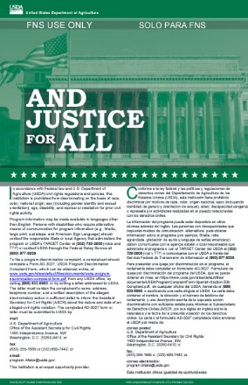
In accordance with federal civil rights law and U.S. Department of Agriculture (USDA) civil rights regulations and policies, this institution is prohibited from discriminating on the basis of race, color, national origin, sex (including gender identity and sexual orientation), disability, age, or reprisal or retaliation for prior civil rights activity.
Program information may be made available in languages other than English. Persons with disabilities who require alternative means of communication to obtain program information (e.g., Braille, large print, audiotape, American Sign Language), should contact the responsible state or local agency that administers the program or USDA’s TARGET Center at 202-720-2600 (voice and TTY) or contact USDA through the Federal Relay Service at 800-877-8339.
To file a program discrimination complaint, a Complainant should complete a Form AD-3027, USDA Program Discrimination Complaint Form which can be obtained online at: https://www.usda.gov/sites/default/files/documents/USDA-OASCR%20P-Complaint-Form-0508-0002-508-11-28-17Fax2Mail.pdf, from any USDA office, by calling 866-632-9992, or by writing a letter addressed to USDA. The letter must contain the complainant’s name, address, telephone number, and a written description of the alleged discriminatory action in sufficient detail to inform the Assistant Secretary for Civil Rights (ASCR) about the nature and date of an alleged civil rights violation. The completed AD-3027 form or letter must be submitted to USDA by:
- mail:
U.S. Department of Agriculture
Office of the Assistant Secretary for Civil Rights
1400 Independence Avenue, SW
Washington, D.C. 20250-9410; or
- fax:
833-256-1665 or 202-690-7442; or
- email:
program.intake@usda.gov
This institution is an equal opportunity provider.

